**PAPER FORMAT:**

**The 2nd International Conference on Chemical Engineering, Food and Biotechnology (ICCFB2015)**

**(*Based on the format of Journal of Science and Technology*)**

* Language of paper is in English.
* Paper size: **A4** (Note: *Custom size* and *letter are not allowed*)
* All paper should be submitted in the ‘Word’ format (.doc or .docx) and its size should be contained under 10 MB

**1. Page setup**

Margin: Top: 3.5 cm

Left: 3.42 cm

Bottom: 4.5 cm

Right: 2.5 cm

**2. Paper content**

Font: Times New Roman

Size: 11

Paragraph: Before: 4 pt;

After: 2 pt;

Line spacing: Single;

First line: 0,8 cm;

Header: 1,27 cm;

Footer: 3,5 cm.

**3. Paper title**

Font: Times New Roman

Size: 14,

Style: Capitalized, Bold, Center

Before: 24 pt,

After: 12 pt;

Line spacing: Single.

*Example:*

PHOTOAUTOTROPHIC MICROPROPAGATION FOR SUSTAINABLE PRODUCTION OF PLANT SPECIES

**4. Authors’ name**:

Font: Times New Roman,

Alignment Center

Size 12

Style: Bold, (capital the first letter of each word)

Before: 18 pt, After: 12 pt.

**5. Affiliation**:

Font: Times New Roman,

Size: 11pt,

Style: Italic

Alignment Center

Author numbering: (1, 2, 3, 4…) super/subscripts

Before: 18 pt, After: 12 pt

*Example:*

**Nguyen Van An1, Le Dinh Thi2, Tran Hai Nam2,\***

*1 Hochiminh City University of Technology*

*2 Hochiminh City University of Natural Resources and Environment*

Mail*: xxxx@xxxxx*

Received date: XX XX 20XX

(Time New Roman; Size 11; Center; Before: 18 pt; After: 12 pt)

Accepted date: XX XX 20XX

(Time New Roman; Size 11; Center; Before: 18 pt; After: 12 pt)

**6. Level 1 - Headings**: Such as: Introduction, Methods and Materials, Results and Discussion, Conclusion, References:

Font: Times New Roman,

Size: 11pt

Style: Bold, UPPERCASE,

Alignment: Center

Before: 18 pt After: 12 pt

*Example:*

**1. INTRODUCTION**

**2. METHODOLOGY**

1. **Level 2 - Headings: such as 2.1, 2.2**,….,

Font: Times New Roman

Size and style: lowercase, bold, 11 pt, before 12 pt, after 12 pt, left

*Example*: **2.1. Materials**

**2.2. Methodology**

1. **Level 3 – Headings: such as:** *2.1.1, 2.1.2*,

Font: Times New Roman

Size and style: Italic, font 11pt, before 12pt, after 12pt, left

*Example:*

*2.2.1. Seed sludge*

*2.2.2. Wastewater source*

1. **Indentions:**  1 Tab = 0,8 cm, before 4 pt, after 2 pt.
2. **Tables**: Font: Times New Roman, size 10
   1. Table title: Center; locate upper Table

Words: Table 1; Table 2…:Italic.

Table content: Lowercase.

* 1. Words and numbers inside tables: before 4 pt, after 2 pt.

*Example:*

*Table 1.* The inhibitory activities of fermented black bean and fermented soybean against α-glucosidase from different microbial sources, %

|  |  |  |  |
| --- | --- | --- | --- |
|  | Source of α-glucosidase | | |
| Type of inhibitors | *Bacillus licheniformis* | *Aspergillus niger* | *Aspergillus oryzae* |
| Fermented black bean | 62 | 65 | 34.7 |
| Fermented soybean | 31 | 22.4 | 13 |
| Acarbose | 64.5 | 37.2 | 2 |

1. **Figures**: Font: Times New Roman

Figure title is located under the figure, size 10 pt, center, before 12 pt, after 12 pt.

Words and numbers inside tables: 8 – 9 pt.

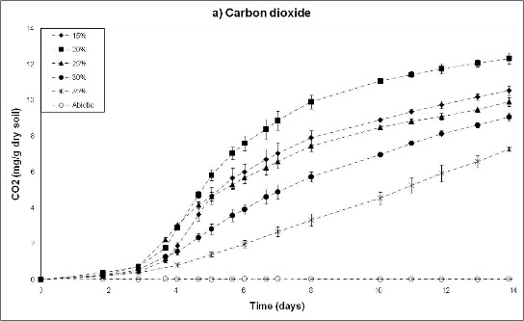 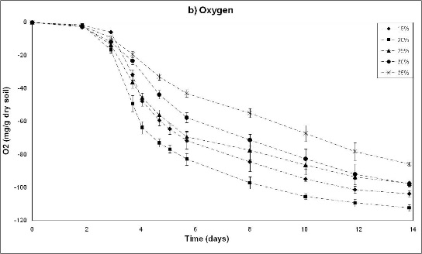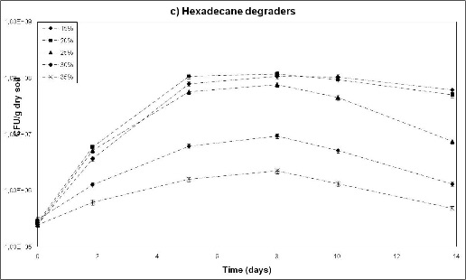 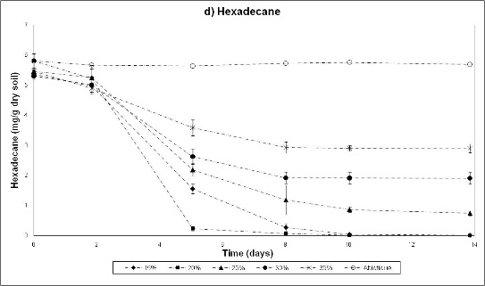

*Figure 1.* Evolution of carbon dioxide (a), oxygen (b), hexadecane degraders (c) and residual hexadecane (d) for five moistures

1. **Acknowledgement .** Left, Italic, Bold, Font: Times New Roman, Size 10, before 12 pt, after 12 pt.

**Acknowledgment**.The authors acknowledge financial support from the Ministry of Higher Education and Research of French Republic

1. **References**:

In the paper text: Indicate references by number(s) in square brackets in line with the text.

Reference list: Number the references in the list in the order in which they appear in the text.

When some part of author’s name are abbreviated, the full word is appeared first and the abbreviated words follows

*Example:* Hulyal S. B. and Kaliwal B. B.; *Not:* S B Hulyal and B B Kaliwal.

- References are clasified into two groups:

**A - Journal**

Author names - Title, Journal title, No.(volume), year, pages.

*Example:*

1. Hulyal S. B. and Kaliwal B. B. - Dynamics of phytoplankton in relation to physico-chemical factors of Almatti reservoir of Bijapur District, Karnataka State. Environ Monit Assess **153** (2008) 45-59.

2. Karlson B., Cusack C., and Bresnan E. - Microscopic and Molecular methods for quantitative phytoplankton analysis, IOC Manual and Guides **55** (2010) 144-156.

**B- Conferences, books, summary record, proceeding…**

Author names – Book title (conference name, …), Publisher, Published location, year, papes

1. Vos P. D., Garrity G. M, Jones D. - Bergey's Manual of Systematic Bacteriology (volume three):The Firmicutes 2nd Ed. New York: Springer, USA, 2003, P. 120-126.

Font: Times New Roman

Style: 11 pt, before 18 pt, after 12 pt.

1. **Abstract**

Font: Times New Roman

Style: 11 pt, Bold, Before 18 pt, After 12 pt.

Length: The abstract should not exceed 250 words

1. **Keywords:** Left, Italic (for the word ”keywords”), Times New Roman, size 11pt, before 12 pt, after 12 pt.

*Example:*

Keywords: hexadecane, biodegradation, contaminated, soil, oxygen, moisture.

1. ***Header and Footer***

***1. Header***

Title of the conference: “The 2nd International Conference on Chemical Engineering, Food and Biotechnology 2015” is used as header for all pages

Font Arial; size 10pt; Italic, left

***2. Footer***

Footer is page number

Style: Outside; font 11pt, times new roman.